Transformations in R

If you want to transform the response variable Y into some new variable Y ', you can add a new column to the data table consisting of the new variable. For our data table named Data, to square the response variable GPA and add it to the data table, type:
> Data <- cbind(Data, Data$GPA^2)
To take its square root, type:
> Data <- cbind(Data, sqrt(Data$GPA) )
To take its natural logarithm, type:
> Data <- cbind(Data, log(Data$GPA) )
To take its common logarithm, type:
> Data <- cbind(Data, log10(Data$GPA) )
To take its reciprocal, type:
> Data <- cbind(Data, 1/Data$GPA )
To take its reciprocal square root, type:
> Data <- cbind(Data, 1/sqrt(Data$GPA) )
And so on. You will want to give the new column in the data table an appropriate name. You can then run a linear model using the transformed response variable and the original predictor.

The Box-Cox procedure chooses an optimal transformation to remediate deviations from the assumptions of the linear regression model. For the linear model College, we give the R commands:
> library(MASS)
> boxcox(College)
and we receive a plot of the "log likelihood" of the parameter λ (lambda) against values of λ from -2 to 2:
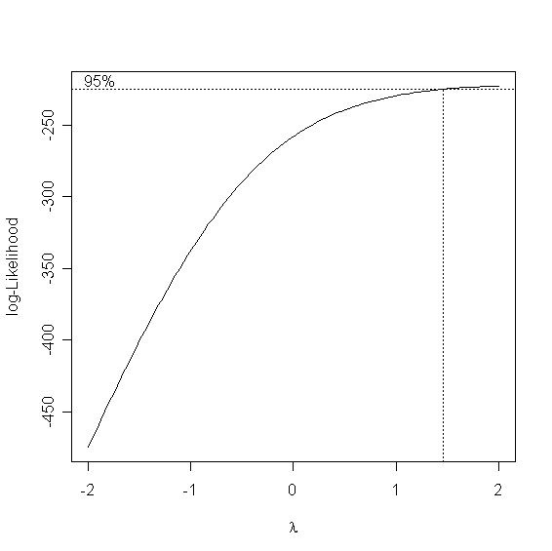
The dotted vertical line indicates that the ideal value of λ is about 1.5. To refine our estimate, we can change the range of λ to, say, from 1 to 2 by steps of 0.1:
> boxcox(College, lambda = seq(1, 2, 0.1))
We then get a new plot:
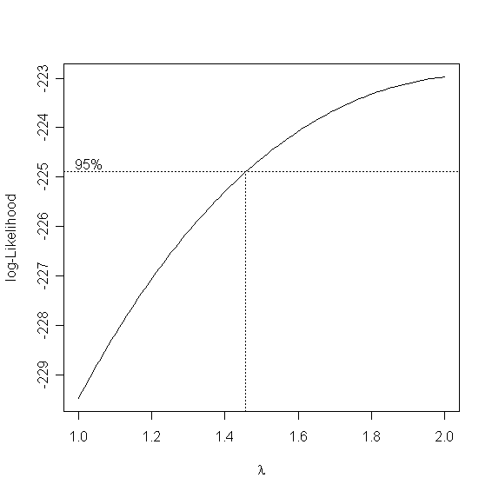

This suggests that the best value of λ is about 1.45. We then transform the response variable accordingly, add it to the original data set, and run a new linear model:
Data <- cbind(Data, Data$GPA^1.45)
names(Data)[3] <- "Yprime"
NewModel <- lm( Yprime ~ ACT,data=Data )

We can check our new model using the various diagnostic tools at our disposal (see the handout "Diagnostics in R"). A normal probability plot of the residuals from the new model (NewModel$residuals) shows that, although there is still some departure from normality, it is much less pronounced:
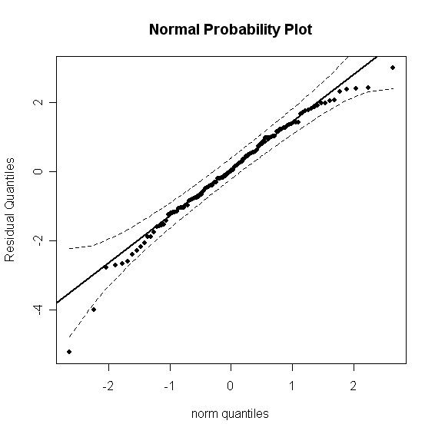
A plot of the residuals from the new model against the predictor shows that the variance is still constant:
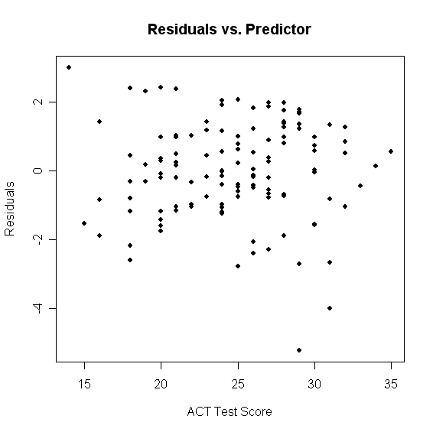
Unfortunately, nothing can be done about the outliers. Finally, a plot of the new regression line along with the transformed data shows that the linear fit is still appropriate:
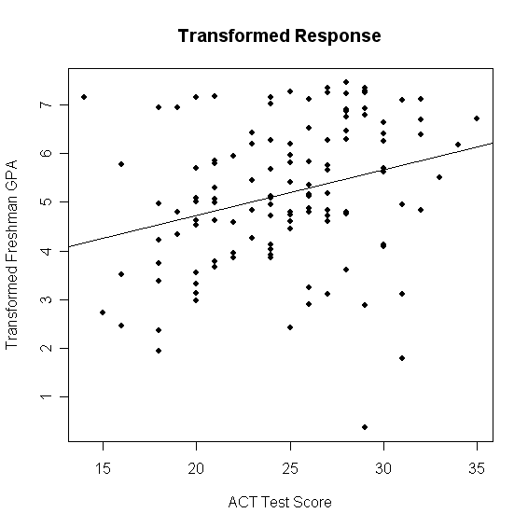
Commands use for the above plots:
> library(car)
> qq.plot(NewModel$residuals, dist= "norm", col=palette()[1], ylab="Residual Quantiles", main="Normal Probability Plot", pch=19)
> plot(Data$ACT, NewModel$residuals, main="Residuals vs. Predictor", xlab="ACT Test Score", ylab="Residuals", pch=19)
> plot(Data$ACT, Data$Yprime, main="Transformed Response", xlab="ACT Test Score", ylab="Transformed Freshman GPA", pch=19)
> abline( NewModel$coefficients[1], NewModel$coefficients[2] )

